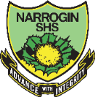 **NARROGIN SENIOR HIGH SCHOOL** 

**English Year 7 NAEP**

|  |
| --- |
| **Student: Teacher: Date Due: T3, W7** |
| **Assessment Type and weighting:** Reading & Viewing 5%, Writing 5%  **Task 6:** Create your own picture book for a Year 7 audience with a rationale which focuses on your Year 7 journey.  **Mark: / 100** |

|  |  |  |  |
| --- | --- | --- | --- |
| **To be assessed for this task you must submit:** | **Date Due** | **YES** | **NO** |
| Picture book storyboard and drafts |  |  |  |
| Picture book (good copy) |  |  |  |
| Rationale |  |  |  |

Comment:

**MARKING CRITERIA**

**Reading & Viewing:** Score: __________

|  |  |  |  |
| --- | --- | --- | --- |
|  | **A**  Excellent achievement  80-100 | **B**  High achievement  65-79 | **C**  Satisfactory achievement  50-64 |
| **Text structure** | Explains how a text can be constructed to appeal to their intended audiences and to promote particular viewpoints. | Describes aspects of a text’s structure that help to promote a viewpoint and appeal to particular audiences in particular contexts. | Identifies how text structures can influence the complexity of a text and are dependent on audience, purpose and context. |
| **Conventions of text** | Explains the way in which specific visual language devices have been used to construct characters and to influence a viewer’s response to them. | Describes ways in which specific visual language devices can be used to construct characters and to influence a viewer’s response to them in a broad sense. | Identifies ways in which visual language can be used to construct characters in a text. |
| **Use of evidence** | Justifies responses and readings of a visual text by drawing on relevant specific examples; demonstrates awareness, where relevant, that visual texts are constructed to promote particular viewpoints. | Demonstrates understanding of a visual text’s viewpoint or position by explaining specific details from the text to support responses and readings. | Selects specific details from a visual text to develop their own response, recognising, where relevant, that visual texts reflect different viewpoints. |

**Writing:** Score: __________

|  |  |  |  |
| --- | --- | --- | --- |
|  | **A**  Excellent achievement  80-100 | **B**  High achievement  65-79 | **C**  Satisfactory achievement  50-64 |
| **Text structure** | Creates an engaging and  well-structured text, such as a narrative, that presents ideas with an effective orientation, well-developed characters, an appropriate conflict and logical resolution. | Creates an engaging and structured text with clear purpose and audience, such as a narrative that includes an interesting introduction, a clear storyline, including a conflict, resulting in an appropriate resolution. | Creates a structured and coherent text for a particular purpose and audience; for example, a narrative with a clear introduction, conflict and resolution. |
| **Spelling and punctuation** | Consistently spells a range of difficult words correctly and accurately uses a range of punctuation. | Correctly spells a range of common and some difficult words and accurately uses some complex punctuation to clarify meaning. | Usually uses common grammar and spelling correctly. |
| **Editing** | Employs a range of strategies to effectively monitor and edit own work to improve accuracy and meaning; for example, adds and/or deletes words to enhance fluency. | Edits and monitors own work for accuracy and to improve clarity; for example, inserts additional or alternative words. | Employs simple strategies to monitor and edit own work for accuracy and meaning; for example, crosses out and rewrites words. |

**Year 7 NAEP English**

**Task 5: Picture Book & Rationale**

**Weighting: 10%**

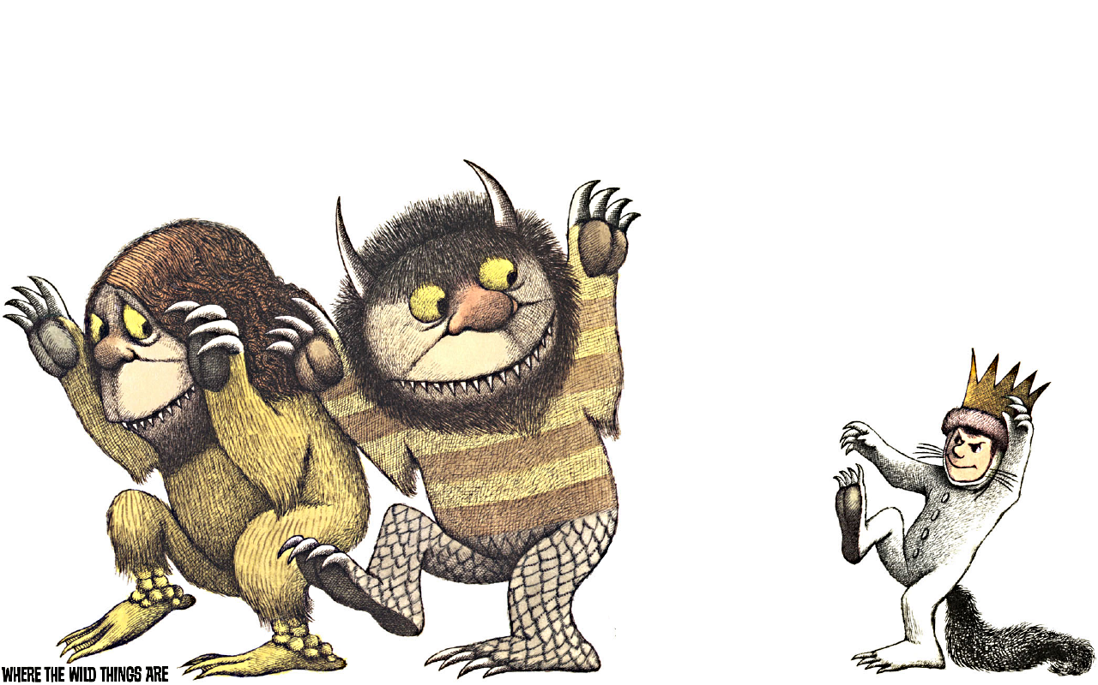

**TASK: Create your own picture book based on your growth as a person and your journey to ‘self.’**

We will be working on this in class and you will plan, prepare and compose your own picture book. Your picture book must:

* be 16 pages long (including covers)
* have between 100 to 400 words
* contain both pictures and text
* be aimed at a Year 7 audience
* have at least one image which bleeds off the page
* have at least one contained image

You will also be required to write a 250-500 word rationale for your picture book that clearly explains your reasoning for how you have illustrated your picture book, your use of language in the text, and **how** the text and the images in the picture book work to create meaning. This may be through elements such as:

* Composition / layout
* Colour symbolism
* Style

In your rationale, you must also consider **what** ***effect*** the overall style of your picture book may have on the reader through examining the convergence or divergence of the images and text, and a statement of how your picture book reflects your journey to ‘self.’

Your submission should:

* look like a picture book and
* include a front and back cover
* have a picture on the front cover to capture the reader’s attention.

**You do not need to include a title page, a copyright page or endpapers.**

***Tips:***

1. You may create your book by hand, or use multimedia such as PowerPoint, Publisher, Storybird (with original pictures) or any other program which you are familiar with.
2. Things to consider when designing your illustrations:

* Gaze
* Angle
* Social distance / proximity
* Motifs
* Shape and line
* Framing (close-up, mid-shot)
* Composition/layout
* Colour, symbolism, and tone.

1. Seek regular guidance, appraisal and feedback from a peer throughout.
2. Ensure you engage the interest of your audience with both your text and illustrations.

**Submission Items**

* This task sheet, marking key and checklist
* completed hard copy of your picture book
* planning and storyboarding
* draft copy of your picture book that has been edited by yourself and at least one peer.

Rationale

**Paragraph 1**

Provide at least one TEES paragraph that clearly explains your reasoning for how you have illustrated your picture book

*Here you would explain how the images in your picture book create meaning. You will need to consider if your picture book is:*

* *Symmetrical – the words and the images have the* ***same*** *information.*
* *Additional information – the images add to the text, and* ***enhance*** *the story.*
* *Alternative information -* ***Counterpoint*** *picture books have words and images that hold* ***alternative*** *information.*
* *Opposite information –* ***Contradictory*** *picture books hold opposite information, where the pictures tell a* ***different*** *story to the text.*

Think about your pictures. Think about how the following create meaning and apply it to how you have used it in your picture book:

* Gaze
* Angle
* Social distance / proximity
* Motifs
* Shape and line (rough lines/soft lines)
* Framing (close-up, mid-shot)
* Composition/layout
* Colour, symbolism, and tone.

Also consider the overall effect and **purpose** of how you have illustrated your picture book, and how it will effect your target audience (Year 7’s).

**Paragraph 2**

You are writing your picture book for a Year 7 audience. Are the words you have used in your picture book suitable for a Year 7 audience? Will they engage a Year 7 audience?

*Here you would think about the number of syllables in your words, your use (or lack of) descriptions in your story and your story as a whole.*

**Paragraph 3**

Provide at least one TEES paragraph that examines how the images and the words work together to create a purposeful **effect** on the reader and **what** the desired effect is. Explain why your picture book is convergent / divergent.

*Here you need to think about the effect you want on the reader. Your target audience is Year 7’s.*

*Here you describe the purpose of your images and your words and what kind of effect you want them to have on the reader. How do you think they are going to react to the images? Think about your images and what kind of picture book you have (convergent/divergent). Think about the purpose of where you have placed the images in your picture book, where you have placed the words, and how that placement creates the desired effect you wanted.*

**Paragraph 4**

Provide at least one TEES paragraph that explains **how** the images. words and the overall story reflect YOUR ‘journey to self’?

*Here you would explain how the images, words and the overall story of your picture book reflects your journey to ‘self.’ How do the images and the words in the picture book provide the best representation of your story? Describe how the words and the images describe your growth as a person, how you’ve changed, and how the images and the words reflect your change.*

How do the pictures and the words work together to create meaning, what is that meaning, and how is that meaning achieved?

**Task 5: Picture Book & Rationale**

**Marking Key Rubric**

|  |  |  |  |  |  |
| --- | --- | --- | --- | --- | --- |
| **Marking Criteria** | **Excellent (4)** | **Good (3)** | **Satisfactory (2)** | **Needs Work**  **(1)** | **N.D. (0)** |
| **Sense of ‘self’**  Creates a narrative with a sense of ‘self.’ The picture book is aimed at a Year 7 audience. | An engaging narrative with a clear sense of ‘self.’ The picture book is clearly aimed at a Year 7 audience. | A well-developed narrative with a sound sense of ‘self.’ The picture book is aimed at a Year 7 audience. | A basic story with a limited sense of ‘self.’ The picture book is mostly aimed at a Year 7 audience. | Attempts to create a narrative with a sense of ‘self.’ The picture book is not aimed at a Year 7 audience. | Does not to create a narrative with a sense of ‘self.’ |
| **Picture book style**  The picture book contains a front cover, back cover, and uses images and text appropriate to the style of the picture book. | Skilfully creates pictures that show a sophisticated connection /disconnection to the text and supports the reader in understanding/ disrupting the narrative through use of colour, layout and picture book conventions. | Creates quality pictures that show a clear connection /disconnection to the text and most pictures support the reader in understanding/ disrupting the narrative through use of colour, layout and conventions. | Creates pictures that show a connection/ disconnection to the text and most pictures support the reader in understanding/ disrupting story. Some adherence to picture book conventions. | Attempts to create pictures, some adherence to picture book conventions evident. | Little or no attempt to create pictures. No adherence to picture book conventions. |
| **Rationale**    The rationale analyses how the images and text create meaning, their effect on the reader, and explains how the picture book reflects the journey to ‘self.’ | An analytical rationale that provides an in-depth analysis on how the images and the text create meaning. A cohesive analysis on how the images and the text work together to create a purposeful effect on the reader. An in depth explanation and reflection on how the picture book as a whole reflects the student’s journey to ‘self.’ | A well-developed rationale that provides an analysis on how the images and the text create meaning. A well-developed analysis on how the images and the text work together to create an effect on the reader. Provides a sound explanation and reflection on how the picture book reflects the student’s journey to ‘self.’ | A rationale that discusses how the images and the text create meaning. Provides a general discussion on how the images and the text work together to create an effect on the reader. Provides an explanation of how the picture book reflects the student’s journey to ‘self.’ May lack sufficient detail. | Attempts to write a rationale discussing how the images and text create meaning, discusses the effect on how the text and images work together to create and effect on the reader. Discusses how the picture book reflects the student’s journey to ‘self.’ May be missing one or more of the above criteria, and/or lacks detail. | Little or no attempt to create a rationale. |
| **Spelling, grammar and punctuation.**  Spelling, grammar and punctuation are utilised effectively in both the picture book and the rationale. | Reads very well, with minor grammatical, spelling and punctuation errors. | Reads well, but with some grammatical, spelling and punctuation errors. | Reads well, but contains grammatical, spelling and punctuation errors. | Contains frequent grammatical, spelling and punctuation errors. | Contains significant grammatical, spelling and punctuation errors. |
| **Planning and drafting**  Planning with evidence of corrections and editing has been submitted. | All elements of the planning and drafting stages have been submitted, with evidence of editing and corrections used to improve the work. | Most elements of the planning and drafting stages have been submitted, with evidence of editing/ corrections guiding the work. | Some elements of the planning and drafting stages have been submitted, with some evidence of editing and corrections. | Limited elements of the planning and drafting stages have been submitted, with limited evidence of editing and corrections. | No evidence of planning and drafting is evident. |

Mark: ________ /20

**Task 5: Picture Book & Rationale Checklist**

|  |  |  |  |
| --- | --- | --- | --- |
| **Picture Book:** | **YES** | **Partly** | **NO** |
| Is my picture book focused on a narrative that clearly indicates my growth and journey to a sense of ‘self’? |  |  |  |
| Do I have images and text on each page of my picture book? |  |  |  |
| Does my picture book contain a front cover, a back cover and a title page (optional). |  |  |  |
| Is the style of my picture book consistent with the style of picture book that I am creating? (e.g. all convergent, all divergent?) |  |  |  |
| Have I used colour, layout, style and other picture book conventions to effectively to tell my story? |  |  |  |

|  |  |  |  |
| --- | --- | --- | --- |
| **Rationale:** | **YES** | **Partly** | **NO** |
| Have I provided at least one paragraph that analyses **how** the images and the word create meaning? |  |  |  |
| Have I provided at least one paragraph that examines how the images and the words work together to create a purposeful **effect** on the reader and **what** the desired effect is? |  |  |  |
| Have I explained **why** I have chosen the type of text I have used (convergent/divergent?) |  |  |  |
| Have I provided at least one paragraph that explains **how** the images. words and the overall story reflects my ‘journey to self’? |  |  |  |
| Is my analysis clear, thoughtful and coherent? |  |  |  |

|  |  |  |  |
| --- | --- | --- | --- |
| **Spelling, punctuation and grammar:** | **YES** | **Partly** | **NO** |
| Have I double checked my spelling with a peer, teacher, or dictionary? |  |  |  |
| Do I have full stops at the end of sentences and capital letters at the beginning of my sentences? Have I used colons, commas and ellipses correctly? |  |  |  |
| Do all of my sentences use correct grammar? (Double check: do they sound right when I read them aloud?) |  |  |  |

|  |  |  |  |
| --- | --- | --- | --- |
| **Planning and drafting:** | **YES** | **Partly** | **NO** |
| Have I remembered to include my planning? |  |  |  |
| Have I remembered to include my draft storyboard? |  |  |  |
| Have I remembered to include my draft picture book? |  |  |  |
| **WAIT:** *Have I edited all of the above and shown evidence of using these corrections to improve my work?* |  |  |  |
| Have I remembered to include a copy of the task sheet and this checklist with my submission? |  |  |  |
| Have I remembered to include my hard copy of my picture book with my submission? |  |  |  |